## **Lab Exercise**

**Ron Jacob Varghese**

**AM.EN.U4CSE19346**

1.Display the path of your current directory.

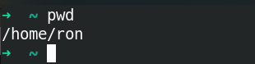

2. Make a new directory named ***main***.



3. Now go to the directory ***main***.



4. Make the directories in the following hierarchy using a single command.

Dir1 -> Dir 2 -> Dir3



5. Print the path of the current directory.



6. Go to ***Dir3*** using a single command.



7. Create a new file ***demo1***, type and save the following contents,

*This is my first file in shell.*

*I can edit this file!!!*

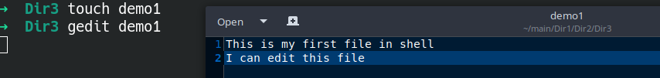

8. Create a new file ***demo2***, type and save the following contents,

*Hi !!! This is the second file.*

*I am doing shell commands.*

*I can edit this file!!!*

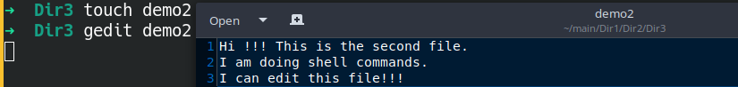

9. Display the contents of file ***demo1*** in terminal.

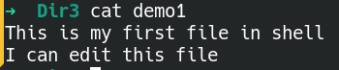

10. List the files and folders present in ***Dir3***.



11. Go to ***Dir 2***.



12. Go to your home directory.



13. Stay where you are, and list the contents of ***Dir3***.



14. List all the files (including hidden files) in your home directory.

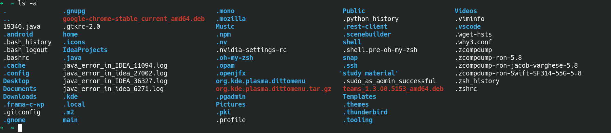

15. Create a new file **test1**, type and save the contents into your file.

*I am working with linux shell.*

*Good bye*

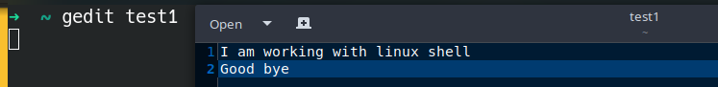

16. Copy the contents of **test1** to **test2** in the same directory.



17. Rename **test2** as **test3**.



18. Determine the file type of **test3**.



19. Move the file **test3** to the directory Dir3.



20. Create a file **count**, with content one to twenty in words with one line having only one number using a single command.

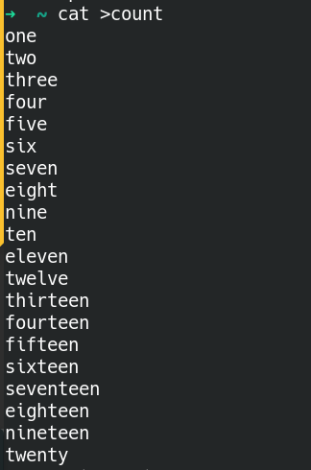

21. Copy the file **count** to **count2** using cat command.



22. Create another file **count3** with numbers twenty one to twenty five (in five lines).

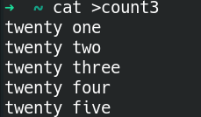

23. Concatenate the contents of files **count2** and **count3** and write it into the file **countfinal**.



24. Remove the files **demo1** and **demo2** in directory Dir3.



25.Go to Dir2 and remove the subdirectory Dir3

.

26. Come back to your home folder and remove Dir2.



27. Display first 10 lines of the file **countfinal** in terminal.

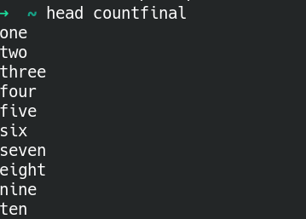

28. Display last 10 lines of the file **countfinal** in terminal.

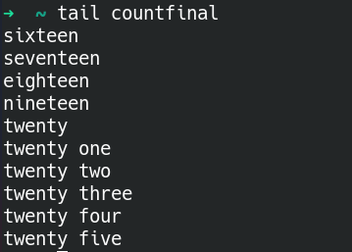

29. Display first 5 lines of the file **countfinal** in terminal.

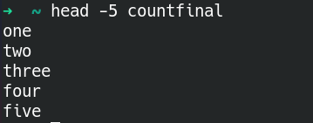

30. Display last 4 lines of the file **countfinal** in terminal.

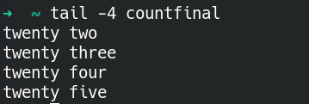

31. Display the contents of the file **countfinal** in the inverted form.(last line first and first line last)

